
Department of Artificial Intelligence and Machine Learning

Course Name | Service Learning
Name of Student | Priyansh Pandey
PRN No. | 24070126143
Class | AIML – B
Academic Year & Semester | 2026-2027 & Semester -5
15 days duration of work done
  Dates | Time
  18/07/2026 | 6:00pm-8:00pm
  19/07/2026 | 10:00pm-2:30pm
  26/07/2026 | 6:00pm-8:00pm
Title of Assignment: | Progress report No. 2
NGO Name with Address | Reform Social Welfare Foundation,  G1, Park Ridge,  Pashan - Sus Rd, Pashan, Pune, Maharashtra 411021
- 1. Problem Statement:
Answer: : Lack of systematic biodiversity mapping limits effective conservation.
2. Objectives of the Work:
Answer:
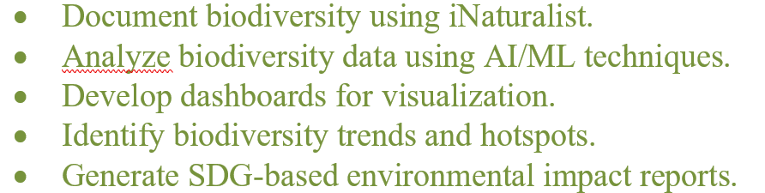
2. Log Book Photo Submission Guidelines:
Answer

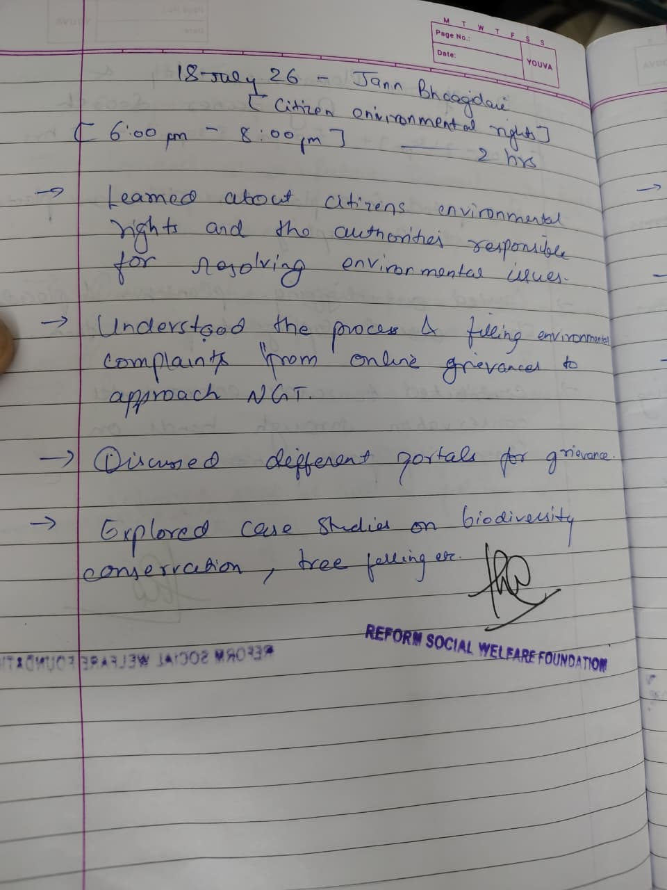
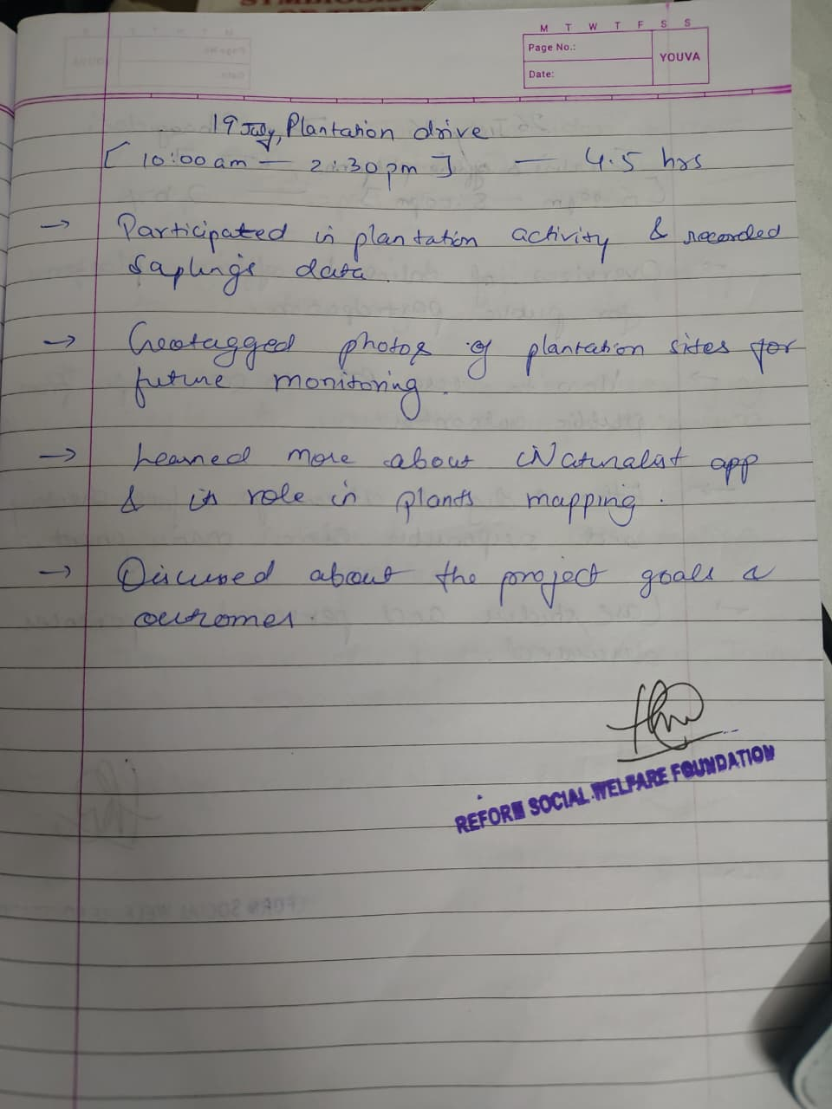
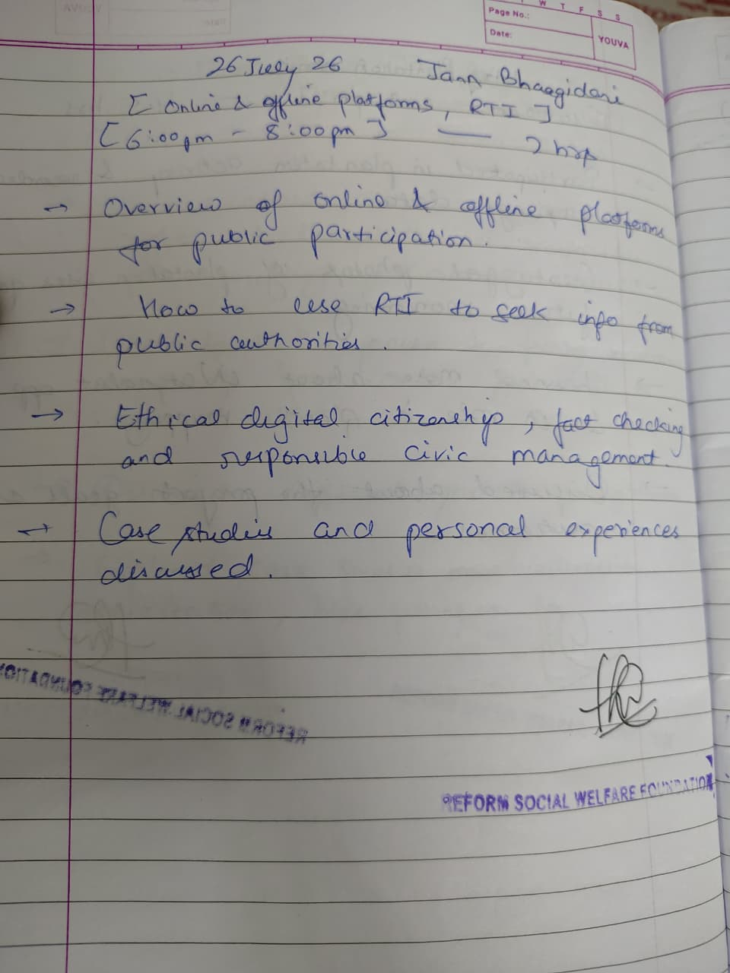
2. Geo-Tagged Photo Submission Guidelines:
Answer
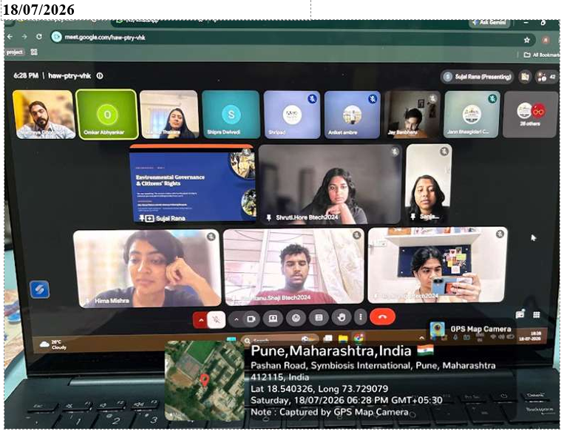
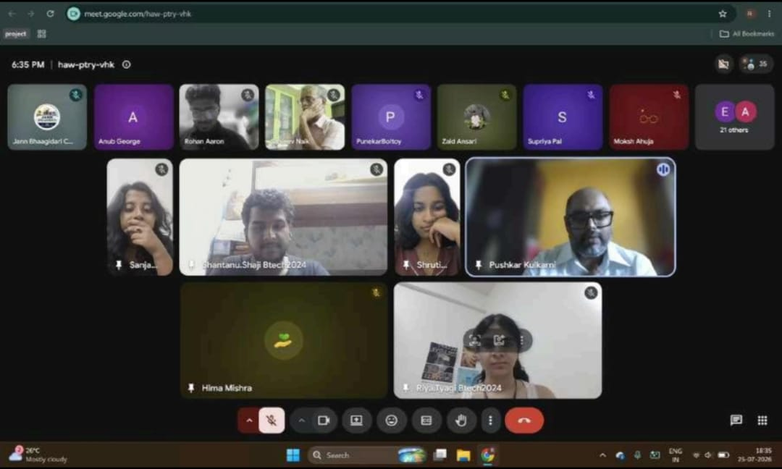
FIG : JAN BHAGIDARI SESSION

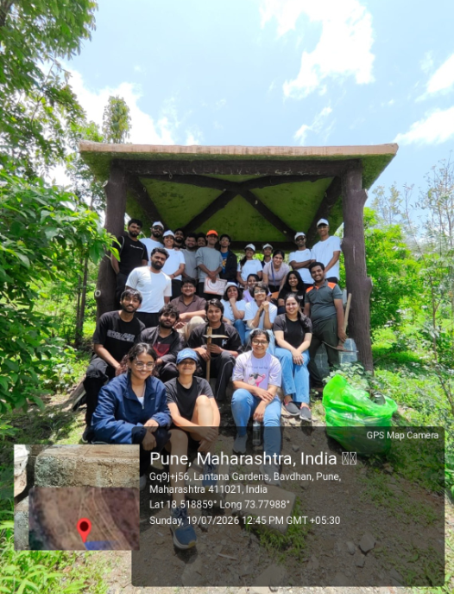
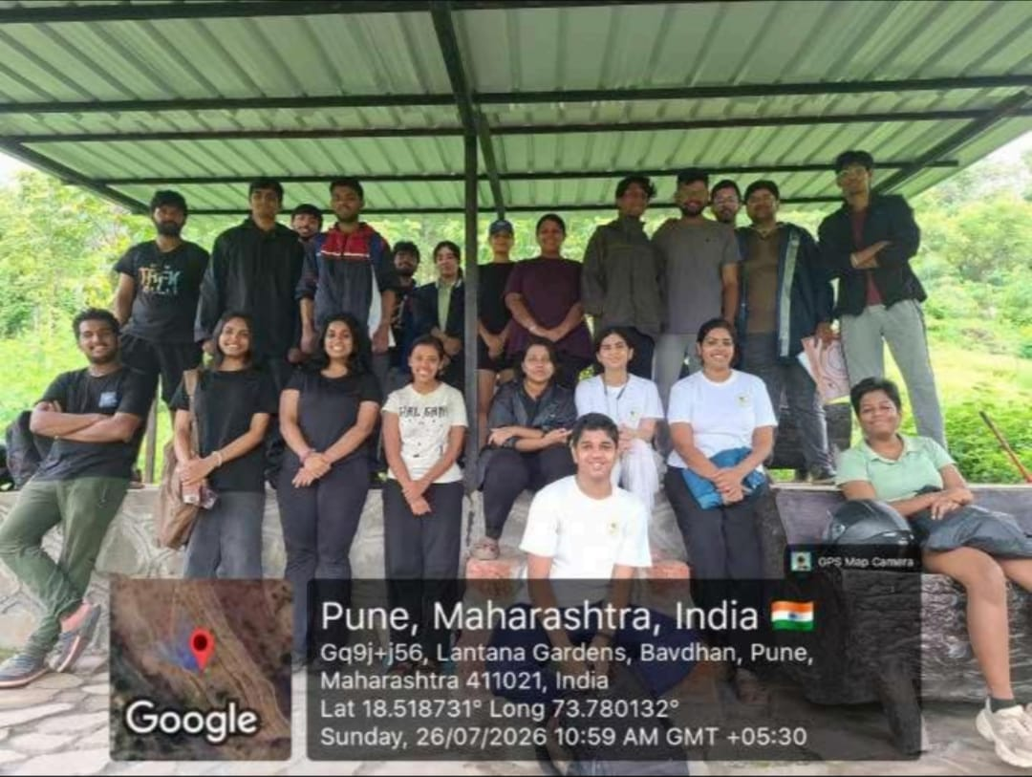

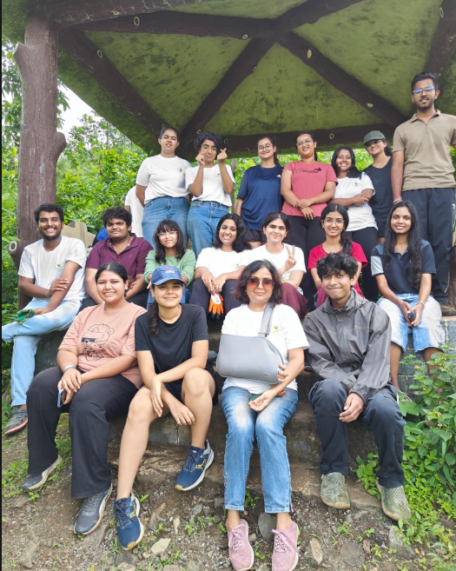
Fig : GROUP PHOTO

